Digitalization and Financial Inclusion among Women-Led Micro and Small Enterprises in Indonesia: An Empirical Perspective
Korespondensi
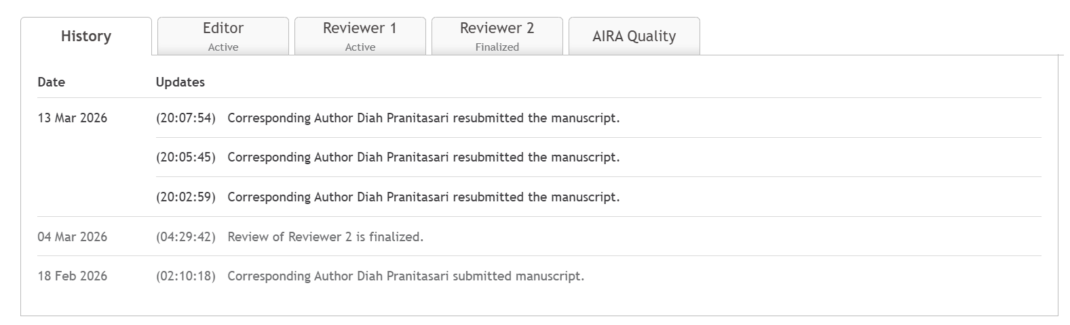
Reviewer 1 | 27 Feb 2026 | 01:19
#1
Theoretical Contribution.
The theoretical contribution is weak. The model only replicates established SMEs and financial literacy relationships model. The capacity-performance gap is introduced but not conceptually developed. The manuscript also treats gender descriptively, not theoretically. All in all, the manuscript lacks clear theoretical advancement for sociological field. For a strong theoretical contribution, the study must demonstrate how its findings extend or refine existing sociological debates, such as gendered access to economic institutions, structural barriers in informal economies, or digital transformation of labor regimes.
Conceptual Model.
The structural model operates primarily at the individual psychological level while sociological model is expected. It can be done by incorporating, such as, institutional context, power relations or systemic inequalities. The manuscript does not also elaborate how the research hypotheses are developed. To strengthen the model, the authors should articulate, for example, how structural gender regimes or institutional constraints are embedded within the framework.
Methodological Rigor.
The explanation of the statistical procedures are insufficiently elaborated with and the section lacks of appropriate methodological references. Additionally, the integration of quantitative and qualitative method is only explained in the discussion section without elaborating how the integration was conducted.
Manuscript Contribution.
Empirically, the manuscript has confirmed well-established relationship model between digital access, motivation, financial literacy, and business performance. However, these finding are not substantially novel within the broader SMEs literature. The qualitative findings in regard to asset ownership, religious perceptions of credit, and dual domestic roles provide important contextual depth but these insights require stronger theoretical elevation to be seen as a contribution to sociology. The manuscript can achieve stronger impact by deeply elaborating theoretical integration and clearer articulation of how these findings reshape understanding of gendered economic inclusion.
Reference Quality.
The manuscript draws on a broad range of references, however, the overall scholarly positioning is uneven. A substantial portion of citations consists of local journals, news articles, or descriptive policy sources which weakens theoretical depth.
Corresponding Author: Diah Pranitasari | 13 Mar 2026 | 19:47
#2
We extend our deepest gratitude to the reviewers for their very constructive comments, criticisms, and suggestions. Their input was very helpful in improving the conceptual clarity, theoretical framework, methodological rigor, and academic positioning of this manuscript. We have thoroughly revised the manuscript to address each of the reviewers' points. Our detailed responses are presented below.
1. Theoretical Contribution
We greatly appreciate these important remarks. To address these comments, we have strengthened the theoretical contribution section of the manuscript by developing the capacity-performance gap concept more conceptually within the framework of economic sociology and women's entrepreneurship.
In the revised manuscript, we position the concept within the broader debate on gender-based economic inclusion, particularly regarding the structural barriers women face in accessing economic institutions. This discussion now links individual capacity building (such as digital literacy and financial literacy) with structural conditions that influence women's ability to translate these capacities into economic performance.
Therefore, the concept of the capacity-performance gap in this study is explained as the gap between individual capacity building and achieved economic outcomes, which is influenced by structural factors such as asset ownership, access to financial institutions, social networks, and gender norms that shape women's economic opportunities.
We have added this revision to the Discussion and Theoretical Contributions section.
2. Conceptual Model
Thank you for this very important input. In the revised manuscript, we have clarified the research's conceptual framework by placing individual variables (such as motivation, digital literacy, and financial literacy) within a broader structural context.
Specifically, we have added an explanation of how gender regimes in society, limited asset ownership, and access to economic institutions can shape women's entrepreneurial opportunities. Thus, although the quantitative model in this study operates at the individual level, the interpretation of the research results is conducted by considering the structural and institutional contexts that influence women's entrepreneurial practices.
Furthermore, the hypothesis development section has been revised and expanded to explain the theoretical basis for each relationship tested in the research model.
3.Methodological Rigor
We greatly appreciate this note. To strengthen methodological rigor, we have revised the methodology section by adding a more detailed explanation of the statistical analysis procedures used, including the stages of evaluating the measurement and structural models, as well as relevant methodological references.
Furthermore, we have clarified the mixed methods research design, specifically regarding how qualitative data is used to provide context and explanation for the quantitative results. An explanation of the process of integrating the two methods has now been added to the methodology section so that it does not appear only in the discussion section.
4. Manuscript Contribution
We understand the reviewer's concerns regarding the novelty of the study findings. In the revised manuscript, we have clarified the study's contribution by emphasizing three main aspects.
First, this study identifies a capacity-performance gap in women's entrepreneurship, indicating that improving digital and financial literacy does not always directly improve business performance.
Second, this study shows that women's entrepreneurial success is influenced by structural factors such as asset ownership, access to financial institutions, and socioeconomic networks.
Third, this research provides an understanding of how digital transformation in the informal economy interacts with the gender-based division of labor, which in some cases can actually create additional workloads for women entrepreneurs.
The explanation of this contribution has been strengthened in the Discussion and Conclusion sections.
5. Reference Quality
We acknowledge this note. In the revised manuscript, we have improved the academic standing of the research by adding more references from international journals relevant to the topics of women's entrepreneurship, financial inclusion, and digital transformation.
Some descriptive or non-academic sources have been reduced or replaced with more appropriate scholarly literature.

We once again thank the reviewers for their valuable comments and suggestions. We believe that the revisions have improved the theoretical, methodological, and academic contributions of this manuscript. We hope that these improvements will address the reviewers' concerns and strengthen the overall quality of the manuscript.
Reviewer 2 | 04 Mar 2026 | 04:29
#1
After careful peer review, I am pleased to inform you that your manuscript shows strong potential for publication. Nevertheless, before acceptance, I respectfully request that you make some minor revisions to improve the clarity, depth, and presentation of your paper.
1. Strengths:
- Relevant and timely research focus.
- Women entrepreneurs' MSMEs perspective.
- Clearly defined research gap and novelty.
- The Mixed Methods Approach demonstrates a methodological depth that can enrich the interpretation of results.
2. Weaknesses:
- Introduction: The introduction relies heavily on general statements rather than empirical facts, recent reports, or concrete examples to justify the issue.
- Literature Review: There is no explanation of the grand theory used and how the research variables relate to each other, resulting in the development of relevant hypotheses (H1-H8). It should be supplemented to produce a comprehensive literature review.
- Research Methods: The analytical testing tools, both quantitative and qualitative, are not specified. It is recommended that the analytical tools used be included to produce valid findings.
- Conclusion: Kindly revise the conclusion to explain how the results align with the research objectives. It is also important to include the practical or theoretical implications, acknowledge the study's limitations, and suggest directions for further studies.
- References: Please ensure that all references are formatted according to APA style guidelines. Each reference should include a DOI or URL where available. It is also recommended that most references be sourced from reputable international, scopus indexed journals.
3. Detailed Revision:
The following are the main revision points that need to be addressed:
1) Introduction:
The statements presented in the introduction remain theoretical and will be further strengthened with supporting evidence, such as relevant surveys, reports, or concrete examples.
2) Literature Review:
The grand theory and key definitions of the research variables are not clearly explained and require further elaboration for conceptual clarity. The research hypothesis should be included in the paragraph discussing the relationship between these variables (H1-H8).
3) Method:
The software used for quantitative and qualitative analysis is not mentioned, and this needs to be explained in detail.
4) Conclusion:
The conclusion should clearly link the findings to the stated research objectives. It should also discuss practical or theoretical implications, acknowledge limitations, and suggest directions for further research.
5) References:
Each reference should include a DOI or URL where available. It is also recommended that most references be sourced from reputable international, scopus indexed journals.
6) Tables and Figures:
Ensure that all tables and figures are aligned with the journal's formatting guidelines.
7) Language Polishing:
Kindly perform minor English language polish to improve clarity and fluency in the overall text.

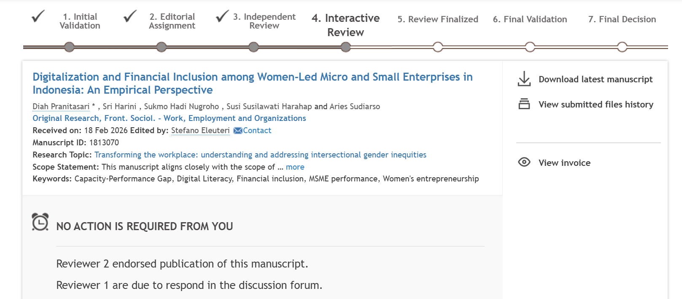
Reviewer 1 | 17 Mar 2026 | 09:38
#3
First and foremost, congratulation to the authors on making the significant improvement on the manuscript. However, significant concerns remain, particularly regarding the methodological explanation of SEM which is insufficient, as key model fit indices and diagnostic tests are not reported. Also, the mixed-methods integration is limited to the interpretation stage, reducing the role of qualitative data to explanatory support.
In detail, the description of the SEM procedure is too thin. The manuscript simply states that the analysis consists of measurement and structural model testing, but stops there. It is not clear what type of SEM is being used (covariance-based or PLS), how the parameters are estimated, or even what software was employed. More importantly, there is no reporting of standard model fit indices such as CFI, RMSEA, or SRMR. Without these, it is not possible to judge whether the model actually fits the data. At the moment, the analysis reads more like a procedural mention than a properly documented method.
Also, The reported threshold (Cronbach's alpha, AVE, t-values) appears without clear justification. There is a reference to "Hair et al.," but it is not really doing any work in the text. The manuscript does not explain why these thresholds are appropriate, nor does it situate the analysis within established SEM practice.
Additionally, the manuscript states that the measurements were adapted from prior studies but not explain from where the constructs were taken, how many items were used, how they were adapted, or whether validated scales were used.
The way of results is reported is also quite limited. Most of the discussion focuses on whether relationships are statistically significant, typically by referring to t-values above 1.96. There is little sense of how strong these relationships are, which variables matter more than others, or how much of the variance the model actually explains. The analysis tends to restate the direction of the relationships rather than interpret them. This makes the results section feel somewhat thin relative to the complexity of the model being tested.
In regard to the qualitative method, the description of qualitative analysis remains quite general. The authors outline standard steps (transcription, coding, and theme development) but do not explain how these were actually carried out in this study. It is unclear whether the coding was inductive or theory-driven, whether more than one researcher was involved, or how any disagreements were handled. As a result, the process is described at a surface level rather than demonstrated in a way that allows the reader to follow the analytical logic. This is compounded by the limited attention to qualitative rigor. There is no discussion of data saturation, nor of how credibility or consistency in the analysis was ensured, and key considerations such as reflexivity or validation are not addressed. Beyond procedural issues, the presentation of findings is also quite compressed. Much of the section summarises what respondents said without showing it directly and there are very few quotations and little sense of variation across participants. Consequently, the analysis reports outcomes but does not fully convey how those insights emerge from the data.
We sincerely thank the reviewer for the constructive feedback. The manuscript has been revised to strengthen the SEM methodology, enhance mixed-methods integration, and provide transparency regarding qualitative rigor.
1. SEM Methodology (Software, Type, & Fit Indices)
Response: We have clarified the use of PLS-SEM via SmartPLS 4. Parameter estimation followed a bootstrapping procedure (5,000 samples). We have also included SRMR as a model fit index, alongside Rsqaure and fsquare values, as per Hair et al. (2021) standards.
Revision: See Sections 3.1 and 4.1.
2. Instrument Adaptation & Thresholds
Response: We added specific details for each construct's origin (e.g., van Deursen & van Dijk; OECD; Ryan & Deci). Threshold justifications for validity and reliability (AVE > 0.5, Alpha > 0.7, HTMT < 0.9) are now explicitly supported by literature.
Revision: See Section 3.1 and Appendix 1.
3. Interpretation of Results & Relationship Strength
Response: The reporting now moves beyond mere statistical significance ($p$-values) to discuss relationship strength via path coefficients ($\beta$) and variance contribution ($R^2$), highlighting the most dominant variables in the model.
Revision: See Sections 4.1 and 5.
4. Qualitative Rigor & Data Integration
Response: The qualitative section now details the coding process (inter-coder consistency), data saturation, and researcher reflexivity. We integrated more direct quotations to demonstrate participant variation and better bridge the quantitative and qualitative findings.
Revision: See Sections 3.2 and 4.2.
We have endeavored to address all the points raised by the reviewer as comprehensively as possible. Should any further information or additional revisions be required, we remain at your disposal to make the necessary adjustments.
Kind regards,
authors
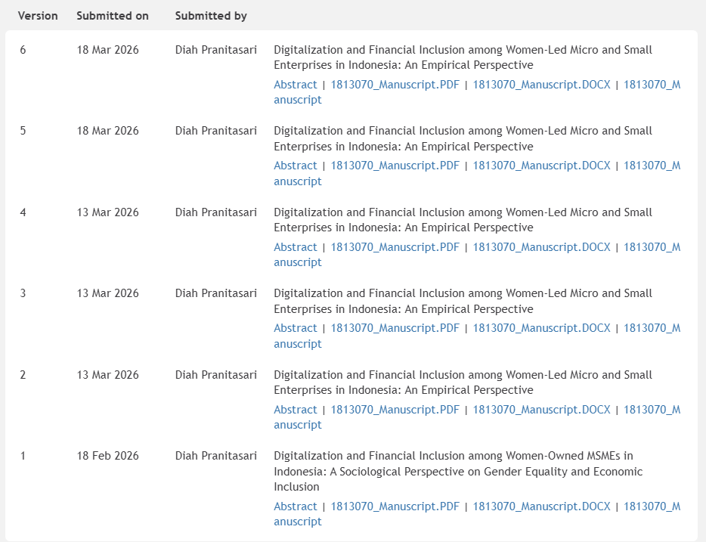
Reviewer 2 (4 Maret 2026)
After careful peer review, I am pleased to inform you that your manuscript shows strong potential for publication. Nevertheless, before acceptance, I respectfully request that you make some minor revisions to improve the clarity, depth, and presentation of your paper.
1. Strengths:
- Relevant and timely research focus.
- Women entrepreneurs' MSMEs perspective.
- Clearly defined research gap and novelty.
- The Mixed Methods Approach demonstrates a methodological depth that can enrich the interpretation of results.
2. Weaknesses:
- Introduction: The introduction relies heavily on general statements rather than empirical facts, recent reports, or concrete examples to justify the issue.
- Literature Review: There is no explanation of the grand theory used and how the research variables relate to each other, resulting in the development of relevant hypotheses (H1-H8). It should be supplemented to produce a comprehensive literature review.
- Research Methods: The analytical testing tools, both quantitative and qualitative, are not specified. It is recommended that the analytical tools used be included to produce valid findings.
- Conclusion: Kindly revise the conclusion to explain how the results align with the research objectives. It is also important to include the practical or theoretical implications, acknowledge the study's limitations, and suggest directions for further studies.
- References: Please ensure that all references are formatted according to APA style guidelines. Each reference should include a DOI or URL where available. It is also recommended that most references be sourced from reputable international, scopus indexed journals.
3. Detailed Revision:
The following are the main revision points that need to be addressed:
1) Introduction:
The statements presented in the introduction remain theoretical and will be further strengthened with supporting evidence, such as relevant surveys, reports, or concrete examples.
2) Literature Review:
The grand theory and key definitions of the research variables are not clearly explained and require further elaboration for conceptual clarity. The research hypothesis should be included in the paragraph discussing the relationship between these variables (H1-H8).
3) Method:
The software used for quantitative and qualitative analysis is not mentioned, and this needs to be explained in detail.
4) Conclusion:
The conclusion should clearly link the findings to the stated research objectives. It should also discuss practical or theoretical implications, acknowledge limitations, and suggest directions for further research.
5) References:
Each reference should include a DOI or URL where available. It is also recommended that most references be sourced from reputable international, scopus indexed journals.
6) Tables and Figures:
Ensure that all tables and figures are aligned with the journal's formatting guidelines.
7) Language Polishing:
Kindly perform minor English language polish to improve clarity and fluency in the overall text.
Jawaban:
Dear Reviewer,
Thank you for your time, attention, and constructive feedback on our manuscript. We greatly appreciate the positive feedback and suggestions for improvement, which have been very helpful in enhancing the quality of this article. Here are our responses and improvements:
1. Regarding the Introduction
Reviewer Comments:
The introduction is still general and needs to be strengthened with empirical data, reports, or concrete examples.
Response:
We have revised the introduction by adding the latest empirical data, including statistics from the Central Bureau of Statistics, government reports, and international studies related to women's MSMEs, digitalization, and financial inclusion. These additions aim to strengthen the research's urgency and provide data-based justification.
2. Regarding the Literature Review
Reviewer Comments:
The grand theory, the relationships between variables, and the development of hypotheses are not yet explained.
Response:
We have improved the literature review section by adding the main theoretical foundations, namely:
- Capability Approach
- Self-Determination Theory
- Financial Behavior Theory
Furthermore, we have clarified the definition of each variable and systematically integrated hypothesis development (H1–H8) into each discussion of the relationships between variables.
3. Regarding Research Methods
Reviewer Comments:
The quantitative and qualitative analysis tools have not been explained in detail.
Response:
We have added a more detailed explanation of the analysis methods, namely: Quantitative analysis using PLS-SEM with SmartPLS version 4 software and Qualitative analysis using Nvivo.
Furthermore, we have clarified the stages of data analysis, including the evaluation of the outer and inner models in SEM.
4. Regarding Conclusions
Reviewer Comments:
The conclusions need to be linked to the research objectives and include implications, limitations, and directions for further research.
Response:
The conclusion section has been revised by:
- Directly linking the research findings to the research objectives
- Adding theoretical and practical implications
- Including research limitations
- Providing recommendations for further research
5. References
Reviewer Comments:
References should follow APA style and include DOIs/URLs, and should be predominantly from reputable journals.
Response:
We have:
- Adapted all references to APA style (latest edition)
- Added DOIs or URLs to each available reference
- Updated and ensured that most references are from international journals indexed by Scopus
6. Tables and Figures
Reviewer Comments:
Needs to be adjusted to the journal format.
Response:
We have adjusted all tables and figures to comply with the journal's formatting guidelines, including numbering, headings, and layout.
7. Language Polishing
Reviewer Comments:
English needs improvement.
Response:
We have conducted a thorough language edit to improve the clarity, consistency, and fluency of English throughout the manuscript.

We are very grateful for the feedback provided, which has helped us significantly improve the quality of the manuscript. We hope that the revisions will meet the expectations of the reviewers and editors.
Sincerely,
Author
