  - AKRUAL JURNAL NASIONAL PERINGKAT 2
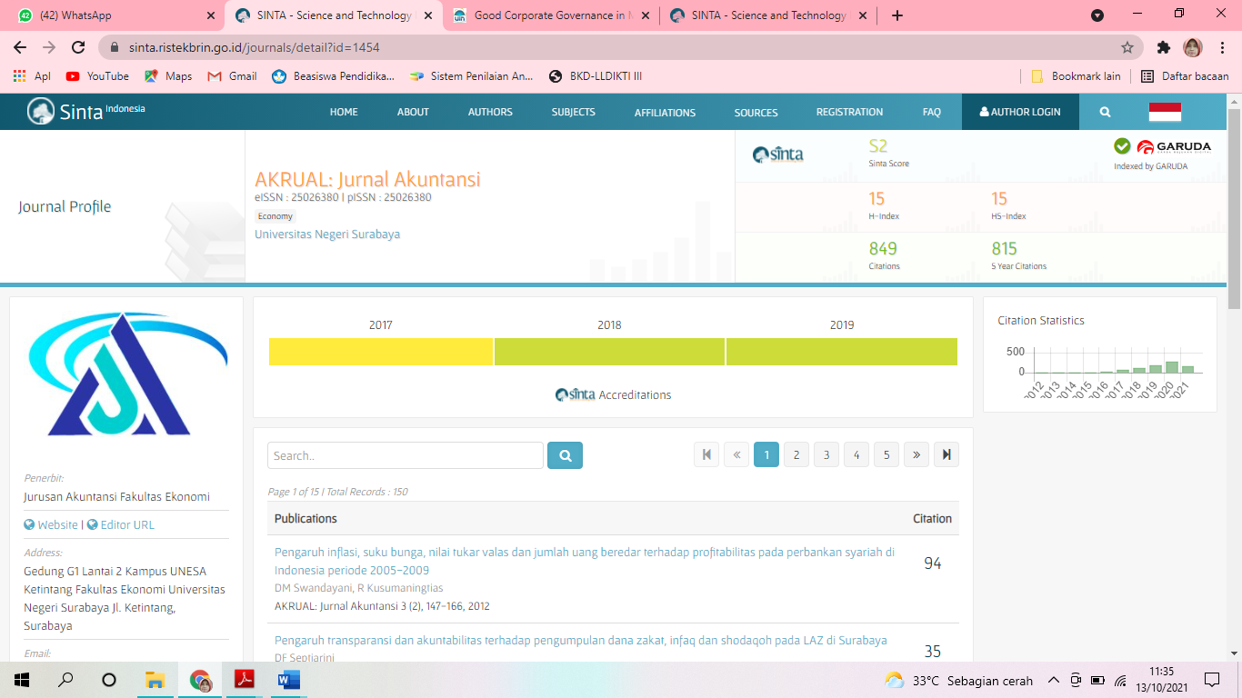

KORESPONDENSI JURNAL AKRUAL (Directives for Sharia Banking Financial Performance in Indonesia: Uun Sunarsih dan Dede Firmansyah)

Revisi 11 April 2018

Revisi 17 April 2018

Diterima 18 April 2018

